**WEB-BASED STUDENT-TO-SUPERVISOR ALLOCATION AND ASSESSMENT SYSTEM**

**PREPARED BY:**

**RICHARD EGHENAYARHIORE EMMANUEL**

**CST20HND0558**

**SUPERVISED BY:**

**MR. ADEOYE, BAMIDELE ADEDAYO**

**NOVEMBER 2022**

**CHAPTER FOUR**

**System Implementation Evaluation**

**4.1 Introduction**

This section provides a concise overview of the implementation process for the new system, ensuring its effective operation. It includes working samples of the newly designed system and outlines the installation procedures.

**4.2 System Testing and Evaluation**

Testing the developed system is essential for various reasons. It allows us to identify any issues or flaws in the new system and provide solutions to address these problems. In this project, a combination of unit and integration testing was employed to verify the effectiveness and efficiency of the design. The testing process also aimed to ensure that the new system meets its functional requirements and operates without errors.

**Unit Testing**

This section focuses on conducting unit testing, which involves evaluating individual units or components of the system separately. The purpose is to ensure that each specific phase or component functions correctly and without any issues. Examining these units in isolation makes it possible to verify their proper operation and identify any potential problems or errors.

**Integration Testing**

Integration testing was employed to test the software, wherein all the components were brought together and operated as a unified system. The objective of this testing phase was to verify the connectivity and proper integration of the various components. By examining the interaction and collaboration between these components, it was ensured that they work seamlessly together and fulfill the intended functionality.

**4.3 System Installation**

In order to use the proposed application on any computer system, the following steps need to be taken:

1. Make sure, pip, pipenv, and python3 or greater are installed on the system.
2. Copy the project folder to any location of your choice.
3. Open the project folder in Visual Studio Code
4. On the terminal run “pipenv install -r requirements.txt”
5. On the terminal run “python manage.py runserver”
6. Open any browser on the system example Chrome, Microsoft Edge, or Mozilla Firefox.
7. On the address bar, type <http://127.0.0.1> and press the enter key the site should be loaded.

**4.4 Security Measures**

Since the scope of the application is public, literally all the information is made available to any user, but some functionalities are restricted to the system admin, project coordinators, and supervisors. Functionalities that have to do with creating student accounts, allocation of the student to a supervisor, the assessment of students, etc. are restricted depending on the user type. The restriction is carried out by using passwords.

**4.6 Sample Outputs**

These descriptions provide a comprehensive overview and visual representation of the program or software. They aim to give a clear understanding of the design by showcasing and illustrating all the interfaces involved.

**Homepage**

This depicts the homepage which is the introductory page of the website. It is the first page that users typically see when they visit a website's domain or click on its link. The purpose of this page is to provide an overview of the website's content, and features

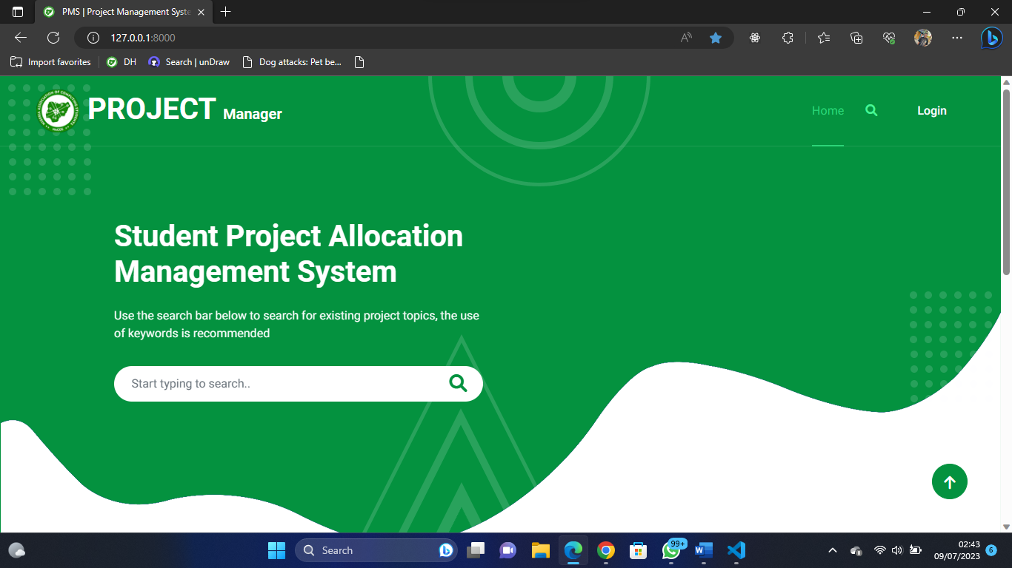

Fig 4.6.1: Homepage

**User Login**

This page serves as a gateway that grants access to the system for specific users, including students, system administrators, and supervisors. However, access is only granted if the correct credentials are provided.

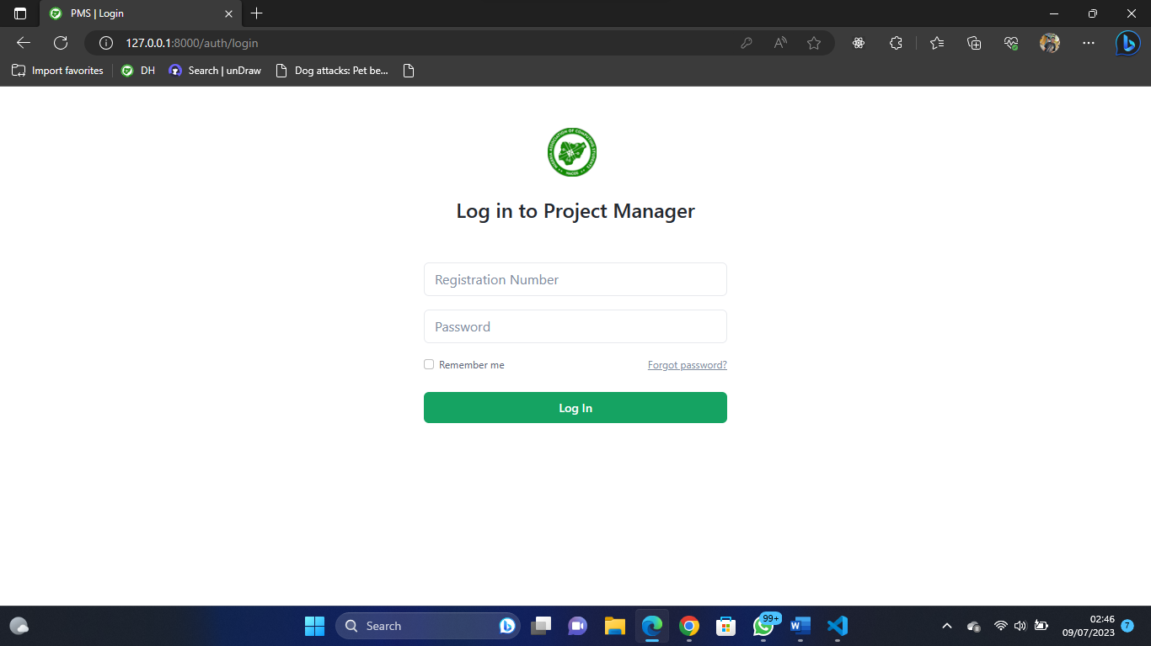

Fig 4.6.2: User Login

**System Admin Dashboard**

This is the system admin dashboard, the sidebar shows the available functionality for the user.

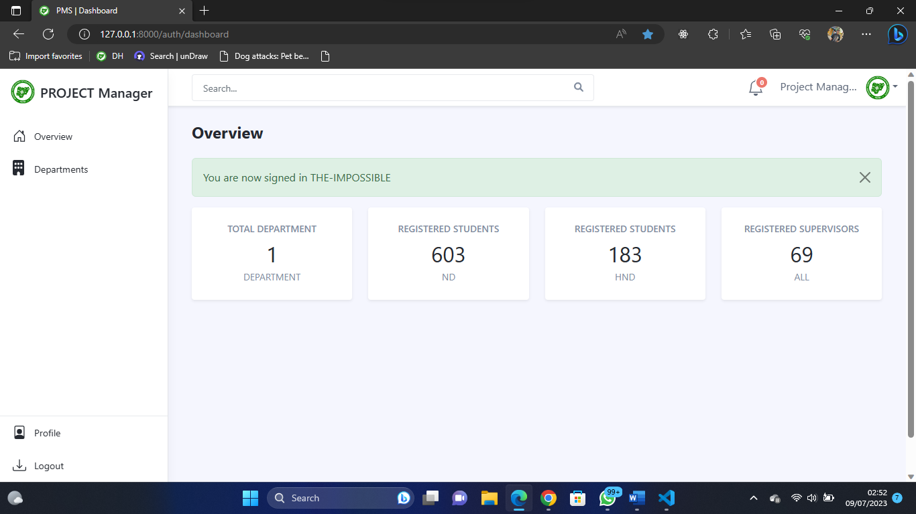

Fig 4.6.3 System Admin Dashboard

**Department Dashboard**

The page appears if the department option on the sidebar is clicked upon, showing the different functionalities that can be performed in the department.

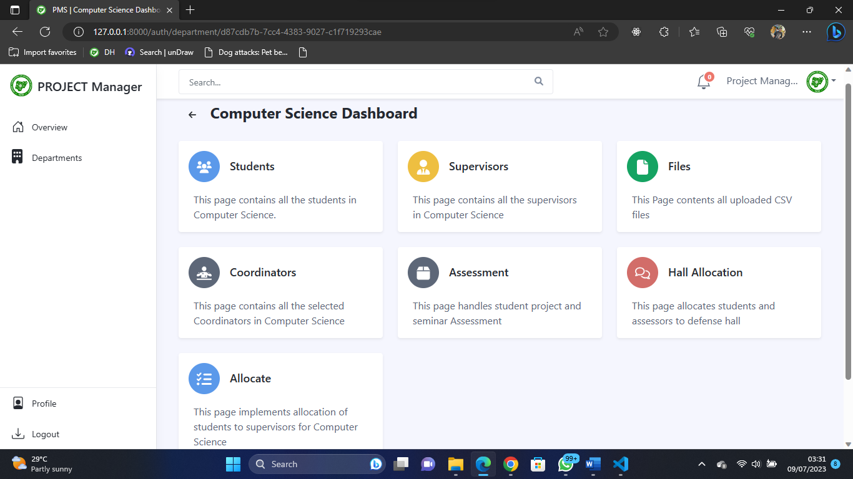

Fig 4.6.4 Department Dashboard

**Allocation Page**

This is the page where the admin can allocate students to supervisors either through auto or manual mode and as well view the allocations.

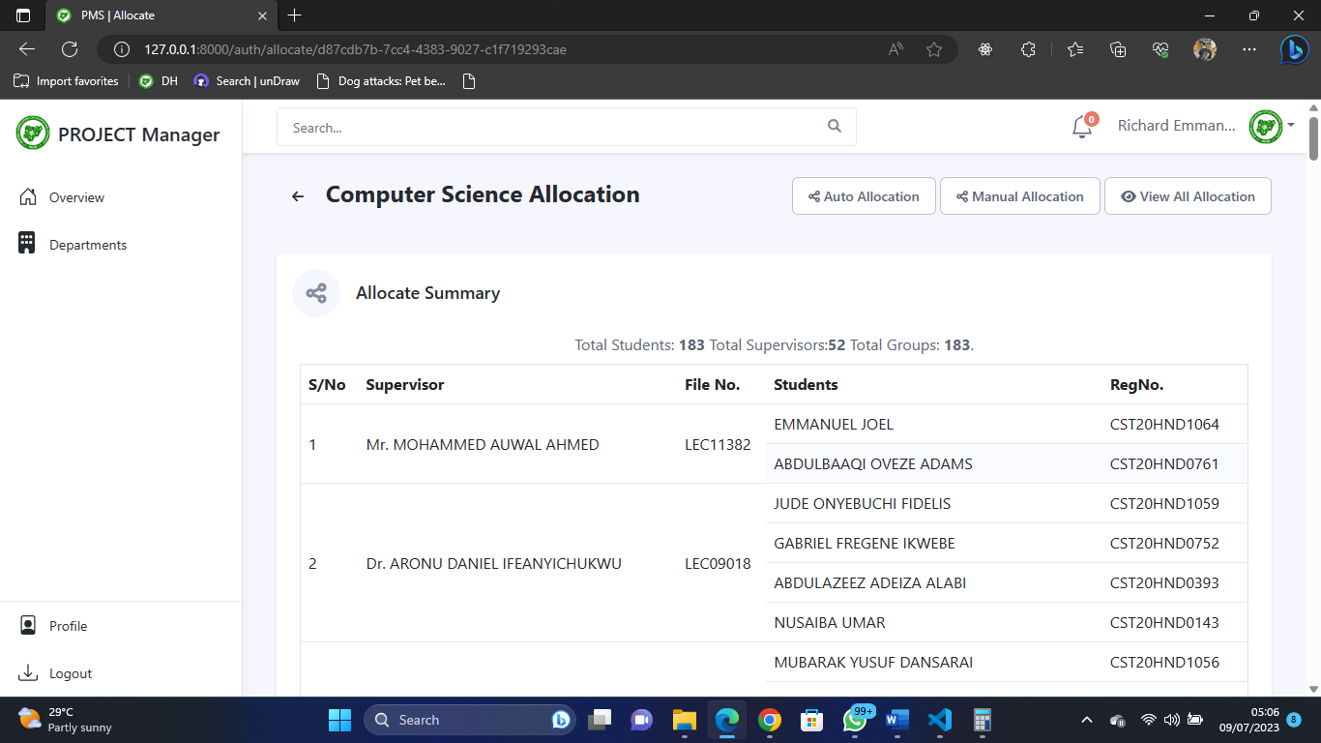

Fig 4.6.5 Allocation Page

**Hall Management Page**

This is the page where the admin can create venues, create numbers of defense days, assign students to halls and defense days, and assign assessors to halls

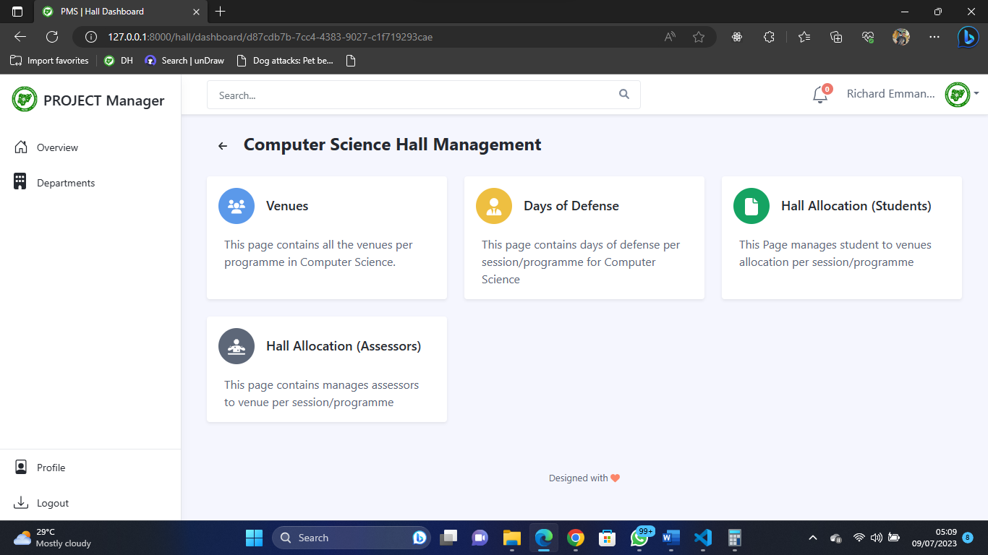

Fig 4.6.6 Hall Management Page

**Student to Venue Allocation**

This is the page where the admin can assign students to halls and defense days.

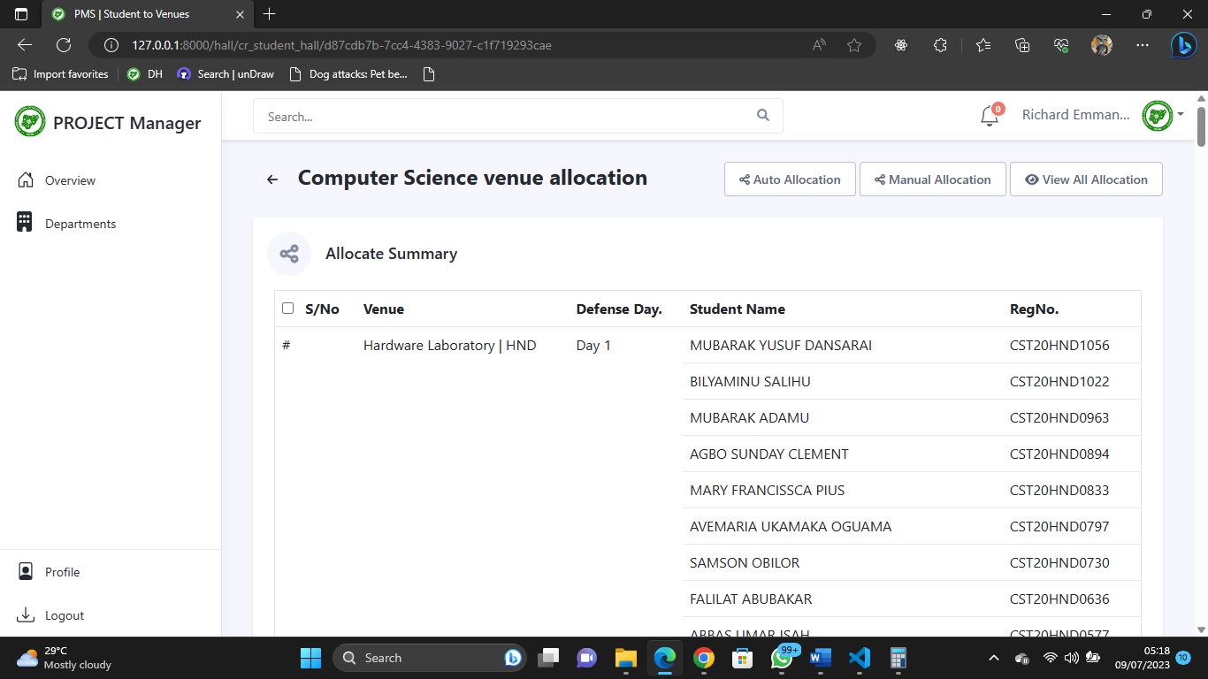

Fig 4.6.7 Student-to-Venue Allocation

**Assessor to Venue Allocation**

This is the page where the admin can assign assessors to venues.

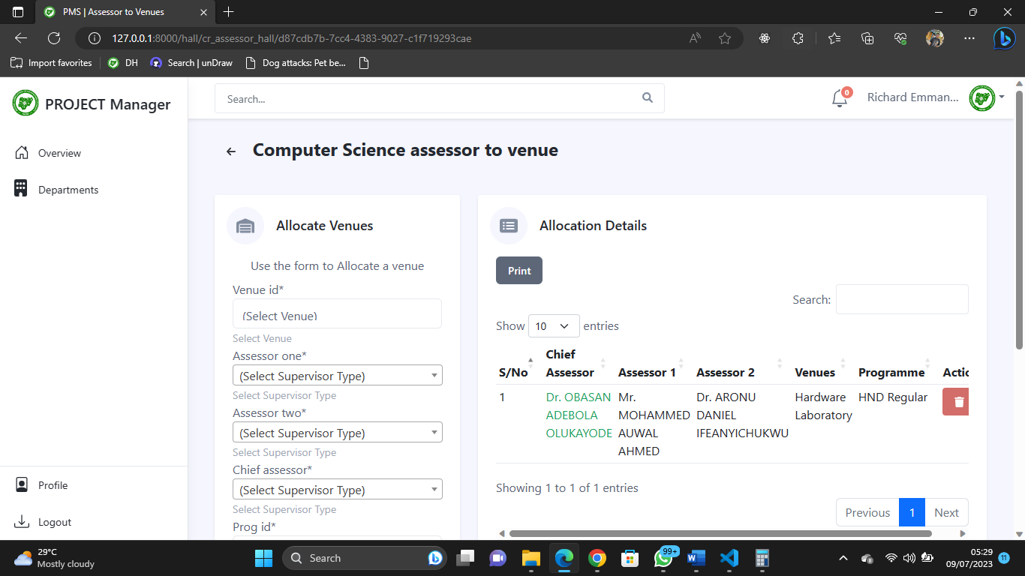

Fig 4.6.8 Assessor to Venue Allocation

**Assessor Assessment**

This is the page where the assessors or coordinators can grade students either for project or seminar

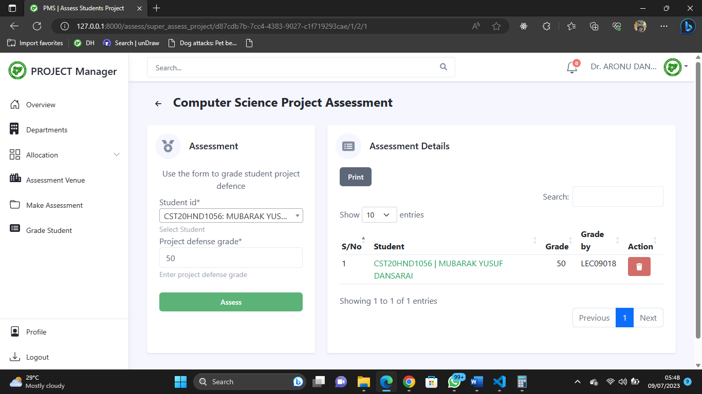

Fig 4.6.9 Assessor Assessment

**Create / Update Coordinators**

This is the page admin can create/update coordinator depending on the programmes

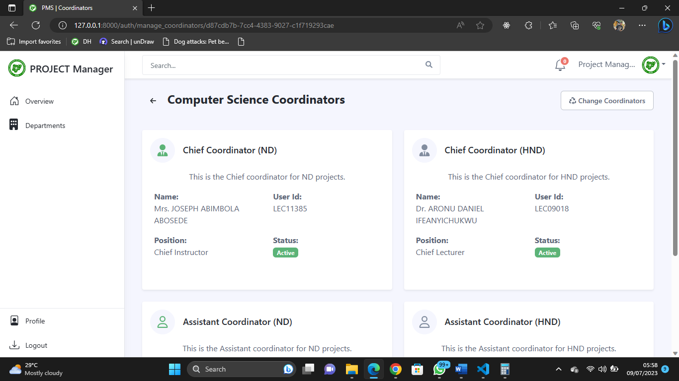

Fig 4.6.10 Create / Update Coordinators

**Student Pages**

**Student Dashboard**

This is the student dashboard the sidebar shows the functionalities available for the student.

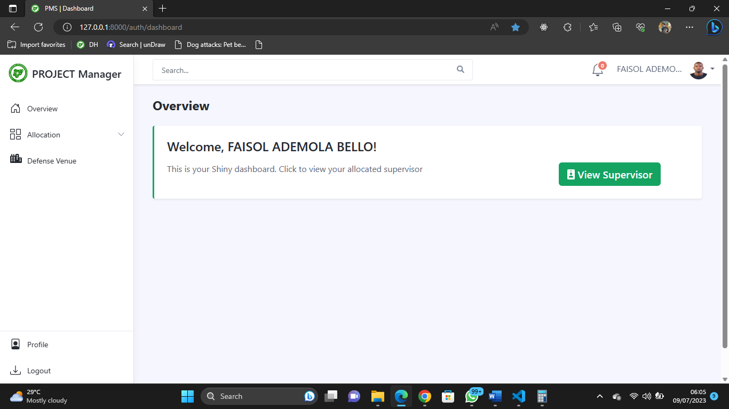

Fig 4.6.11 Student Dashboard

**View Supervisor**

The student can view their allocated supervisors from their dashboard.

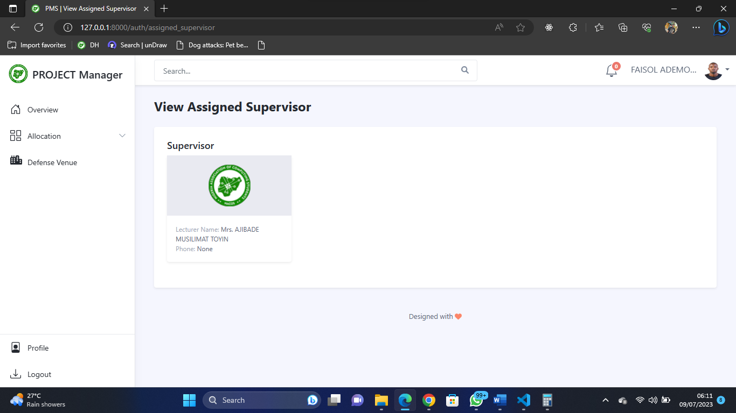

Fig 4.6.12 View Supervisor

**View Venue and Assessors**

The student can view their allocated venues along side the venue assessors from their dashboard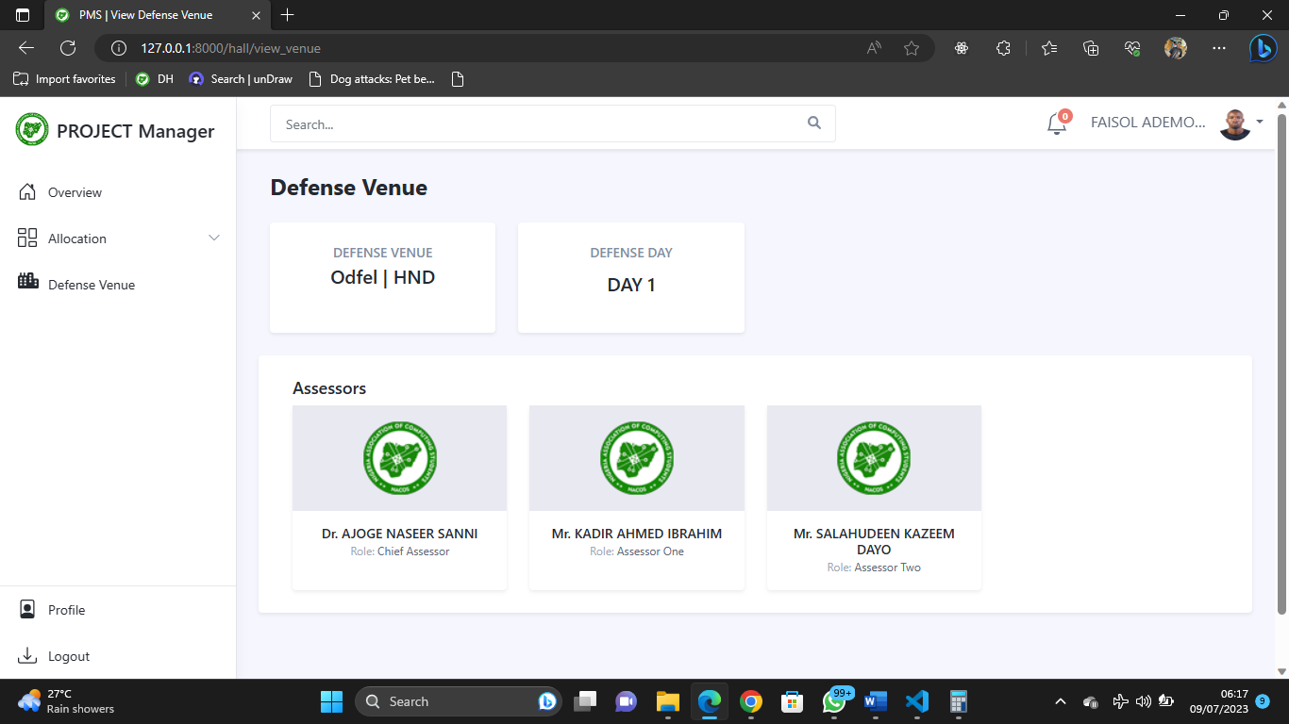

Fig 4.6.13 View Venue and Assessors

**Profile Page**

The logged in user can update their profile or decide to change their password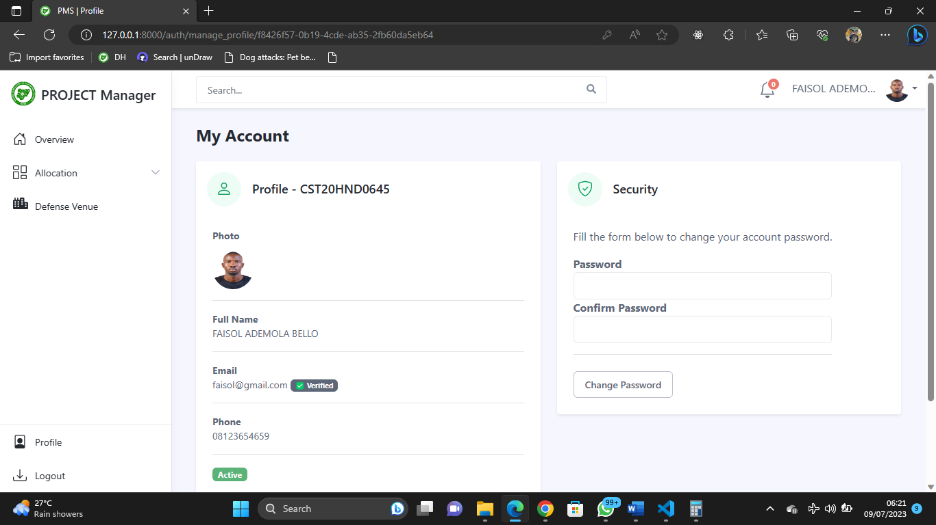

Fig 4.6.14 Profile Page

**Supervisors Page**

**Supervisor Dashboard**

This is the supervisor dashboard the sidebar shows the functionalities available for the supervisor 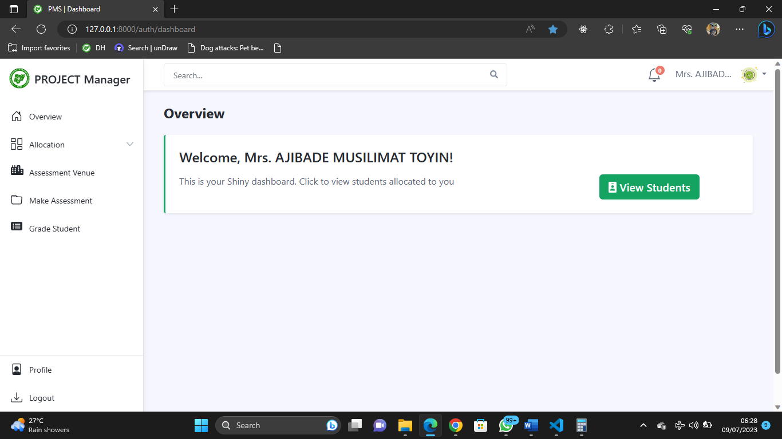

Fig 4.6.15 Supervisor Dashboard

**View Assigned Student**

The supervisor can view the students that are assigned to them

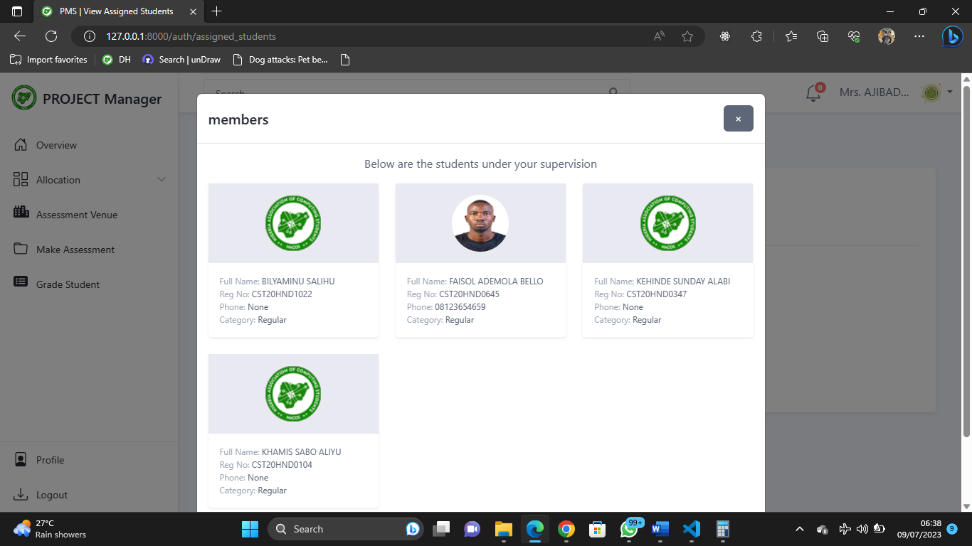

Fig 4.6.16 Supervisor Dashboard

**Grade Project Student**

The supervisor can grade their project students

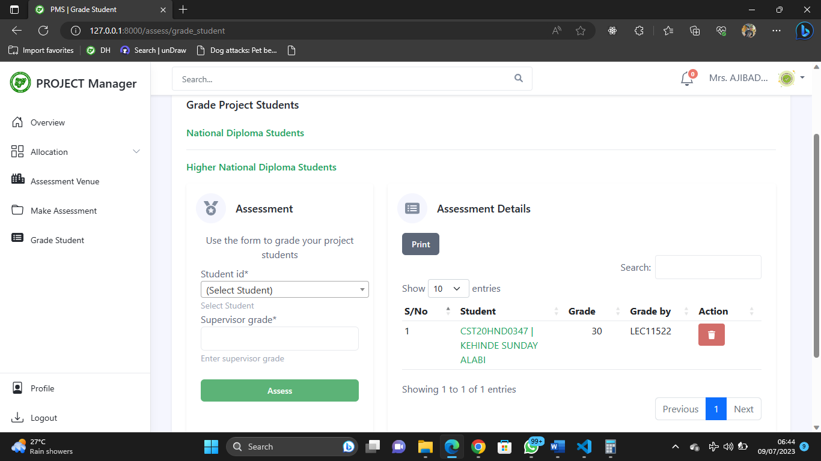

Fig 4.6.17 Grade Project Student

**View Assessment Venue**

The supervisors can view their assessment venues along side other assessors

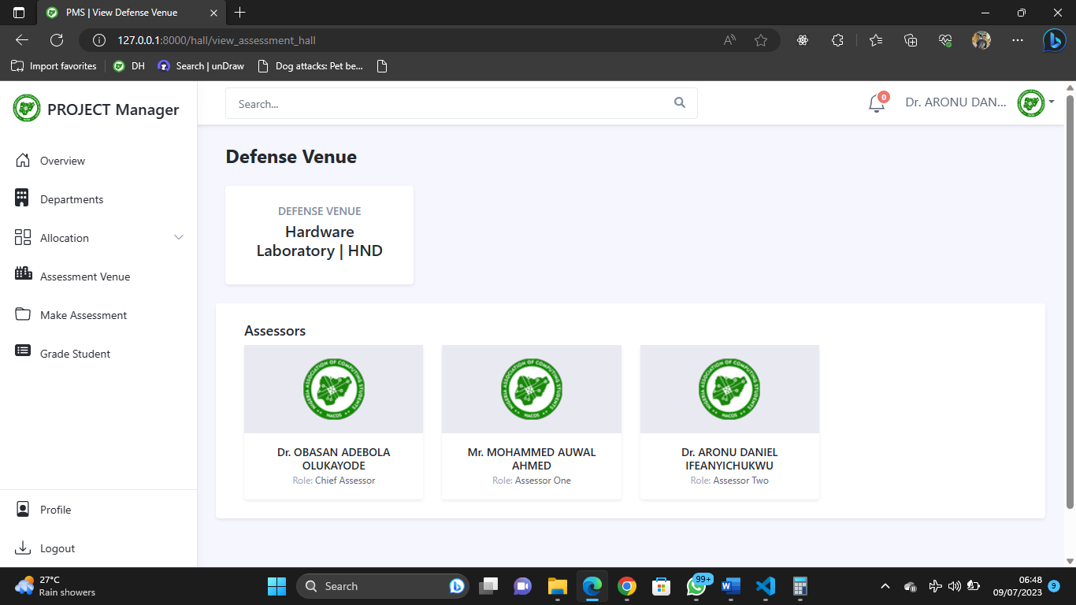

Fig 4.6.18 View Assessment Venue

**CHAPTER FIVE**

**Summary Conclusion and Recommendation**

**5.1 Summary**

This project focuses on the development of a student-to-supervisor allocation and assessment system for the Computer Science department at Kaduna Polytechnic. The system aims to streamline the process of assigning students to supervisors and conducting assessments for student projects and seminar defense. By automating the allocation process and providing a user-friendly web interface, the system enhances work efficiency, improves communication between students and supervisors, and simplifies the assessment procedure. The research utilizes modern technologies and frameworks to create a secure and efficient platform for managing student-supervisor relationships, facilitating effective project management and data handling. This project is significant as it reduces time wastage, improves documentation, and enhances overall productivity in the department's project assessment procedures.

**5.2 Conclusion**

In conclusion, this project has successfully developed a student-to-supervisor allocation and assessment system for the Computer Science department at Kaduna Polytechnic. The system automates the allocation process and provides a user-friendly web interface, improving efficiency and communication between students and supervisors. By streamlining the assessment procedure, the system reduces paperwork and enhances documentation, resulting in more accurate grading. It significantly reduces time wastage in assigning students to supervisors and facilitates effective project management. Overall, this project has made a valuable contribution to improving the project assessment procedures at Kaduna Polytechnic, increasing productivity, and enhancing the overall experience for students, supervisors, and assessors.

**5.2 Recommendation**

Based on the project findings and outcomes, the following recommendations are suggested for further improvement and enhancement:

1. Continuous System Monitoring: It is recommended to establish a process for ongoing system monitoring and maintenance. Regularly monitoring the system's performance, addressing any issues or bugs, and implementing necessary updates will ensure its optimal functionality and reliability.
2. Implementation and Deployment: Proceed with the implementation and deployment of the student-to-supervisor allocation and assessment system to the Computer Science department at Kaduna Polytechnic. Ensure thorough testing and validation before making it operational.
3. Scalability and Flexibility: Consider the future growth and expansion of the system by designing it to be scalable and flexible. This will allow for easy integration of additional features, accommodate a larger number of users, and adapt to changing requirements.

By considering these recommendations, the student-to-supervisor allocation and assessment system can be continuously improved, ensuring its long-term effectiveness and alignment with the evolving needs of the Computer Science department at Kaduna Polytechnic.

**REFERENCES**

Arumugam, V., Singh, P., Padhiyar, K., Manek, R., & Sayyad, S. (2021). Academic Project

Information Management System. *Institute of Electrical and Electronics Engineers Inc*. https://doi.org/10.1109/ASIANCON51346.2021.9544565

Amadi, A. N., Ololo, E. C. (2021); Design and Implementation of Students’ projects allocation

System*. International Journal of Scientific and Research Publications (IJSRP) 11*(6) (ISSN: 2250-3153), https://dx.doi.org/10.29322/IJSRP.11.06.2021.p11424

Django. (2022). “*The web framework for perfectionists with deadlines”* https://www.djangoproject.com/

Hassan, N. (2016). A preemptive goal programming for allocating students into academic

departments of a faculty. *International Journal of Mathematical Models and Methods in Applied Sciences*, 10, 166–170.

Huda, S. S. M., Kabir, Md. & Tanvir S. (2020). E-Assessment in Higher Education: Student’s

Perspective. *International Journal of Education and Development using Information and Communication Technology 16*(2), pp. 250-258

Martin, A., Fanus, V. (2018) E-Assessment in Higher Education: *A Review. International Journal*

*of Business Management and Economic Research (IJBMER), 9*(6),2018, 1454-1460

Ojo, T., M., Shuaibu, N,. Nasir B., S., (2022). Design and Implementation of Student Project

Management and Allocation system: Kaduna Polytechnic, Department of Computer Science

Supianto, K., & Khaerudin. (2020). Web-based project assessment. *International Journal of*

*Psychosocial Rehabilitation, 24*(8). <https://doi.org/10.37200/IJPR/V24I8/PR280689>